Test ID | Feature | Test Description | Input | Expected | Outcome | Status | Evidence
1 | Login | Valid login | Correct details | Dashboard access | Works | Pass | 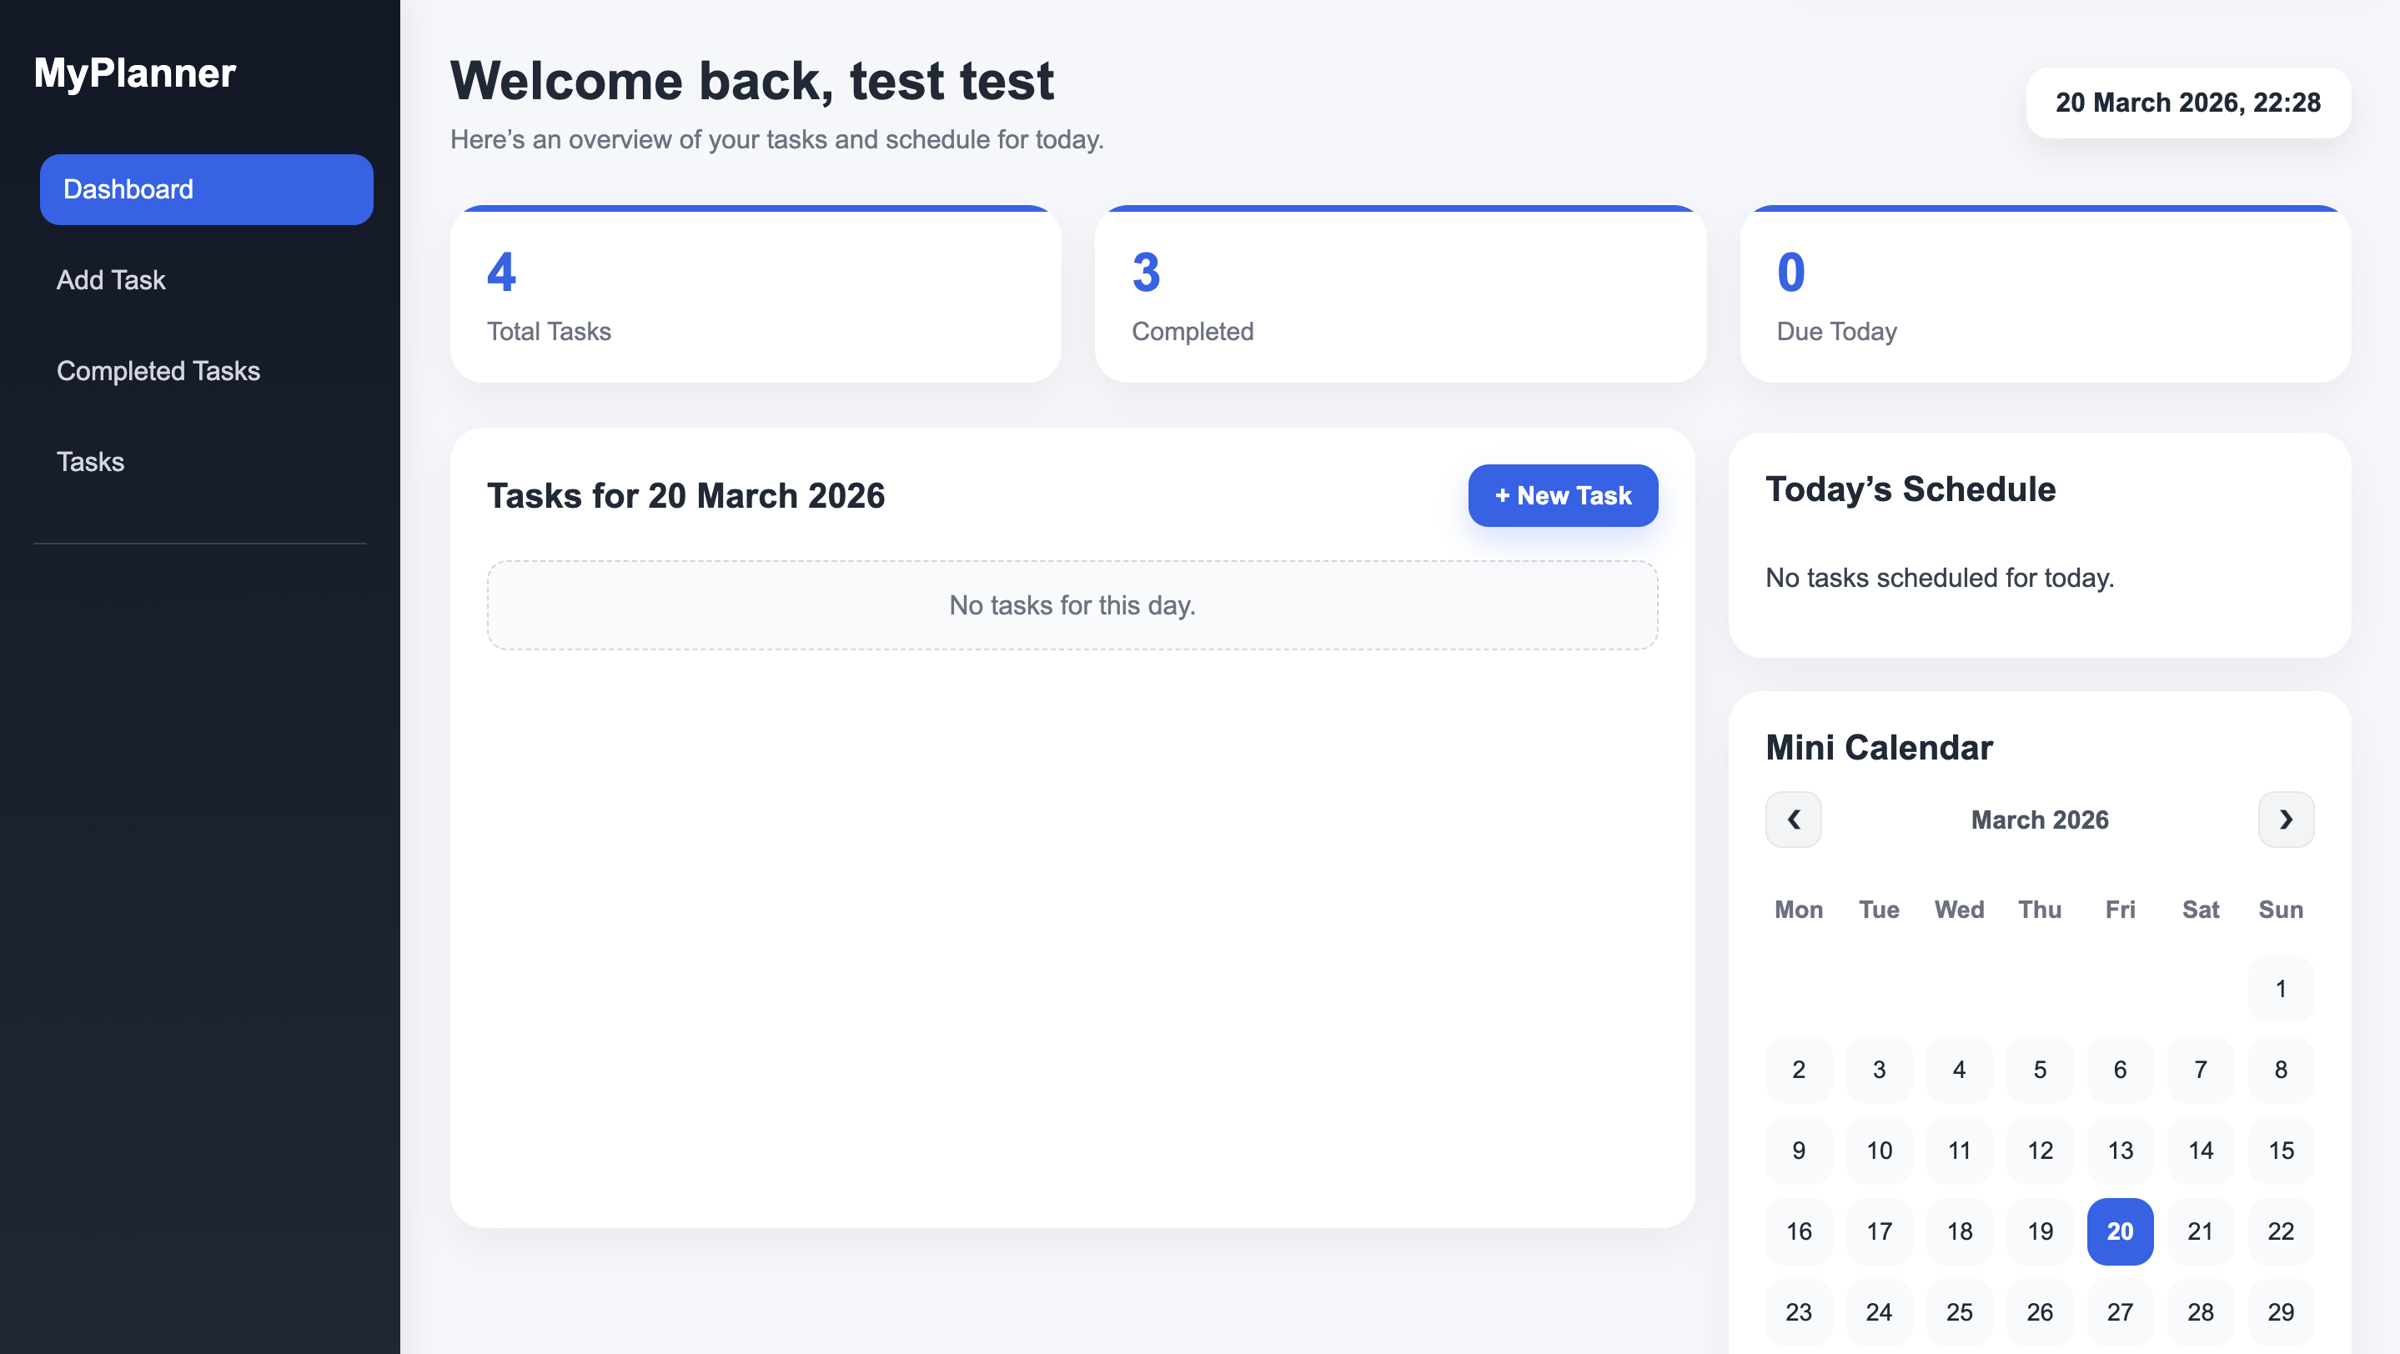
2 | Login | Invalid login | Wrong password | Error shown | Works | Pass | 
3 | Add task | Create task | Valid input | Saved to DB | Works | Pass | 
4 | Add task | Validation | Empty title | Blocked | Works | Pass | 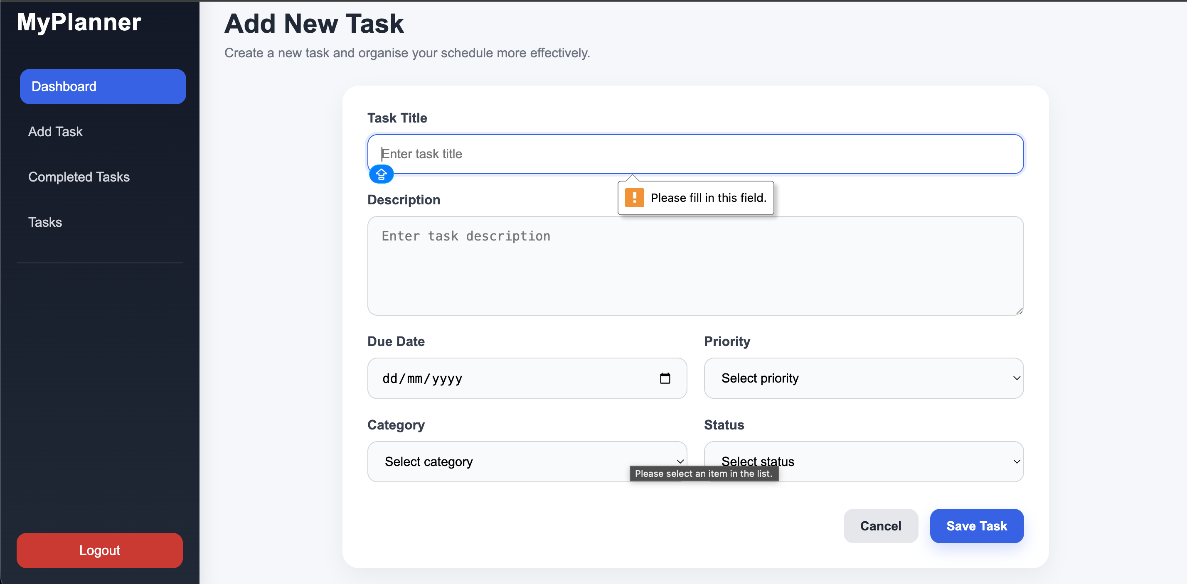
5 | Complete | Mark complete | Click button | Moves to completed | Works | Pass | 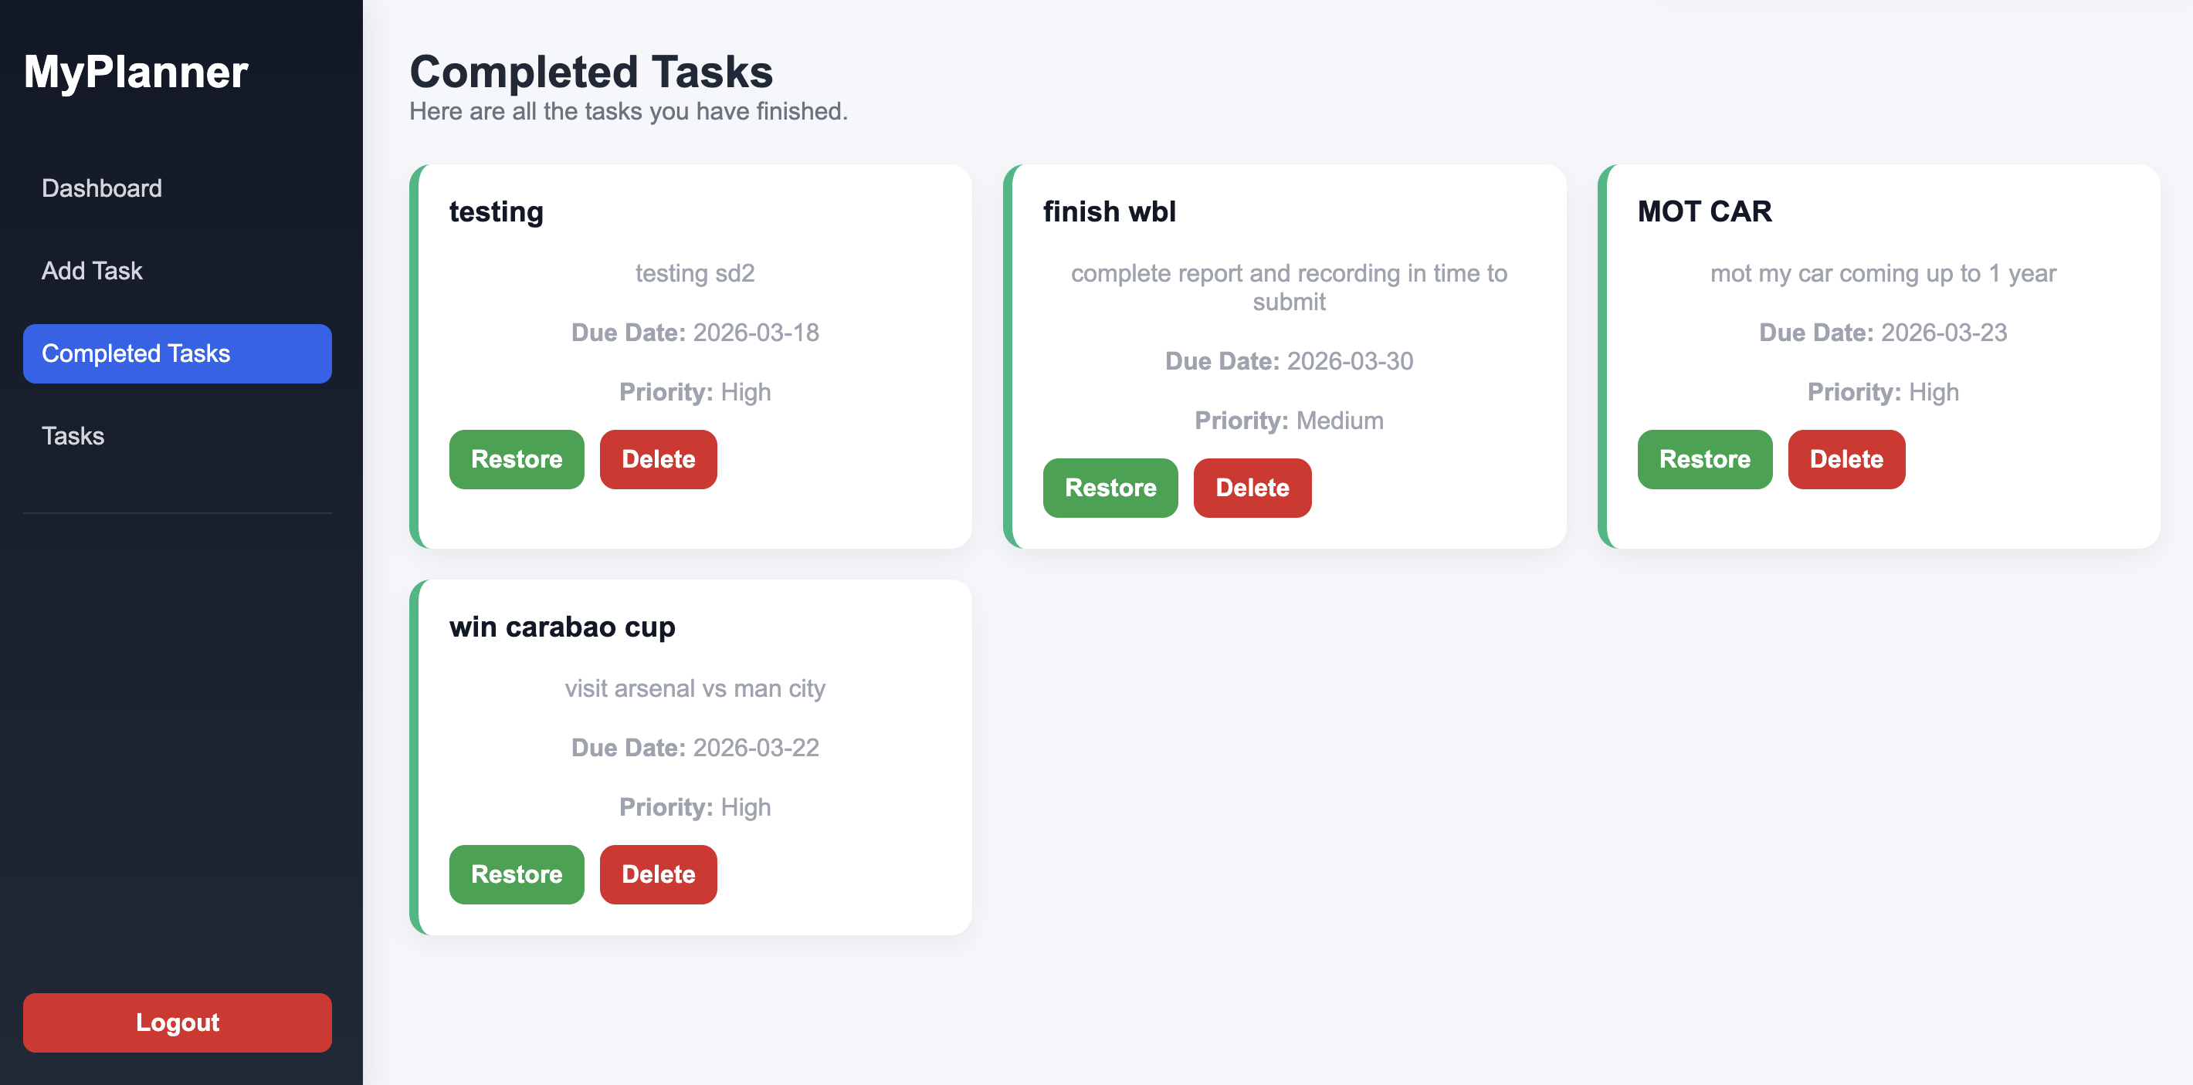
6 | Delete | Delete task | Delete task | Click delete | Works | pass | 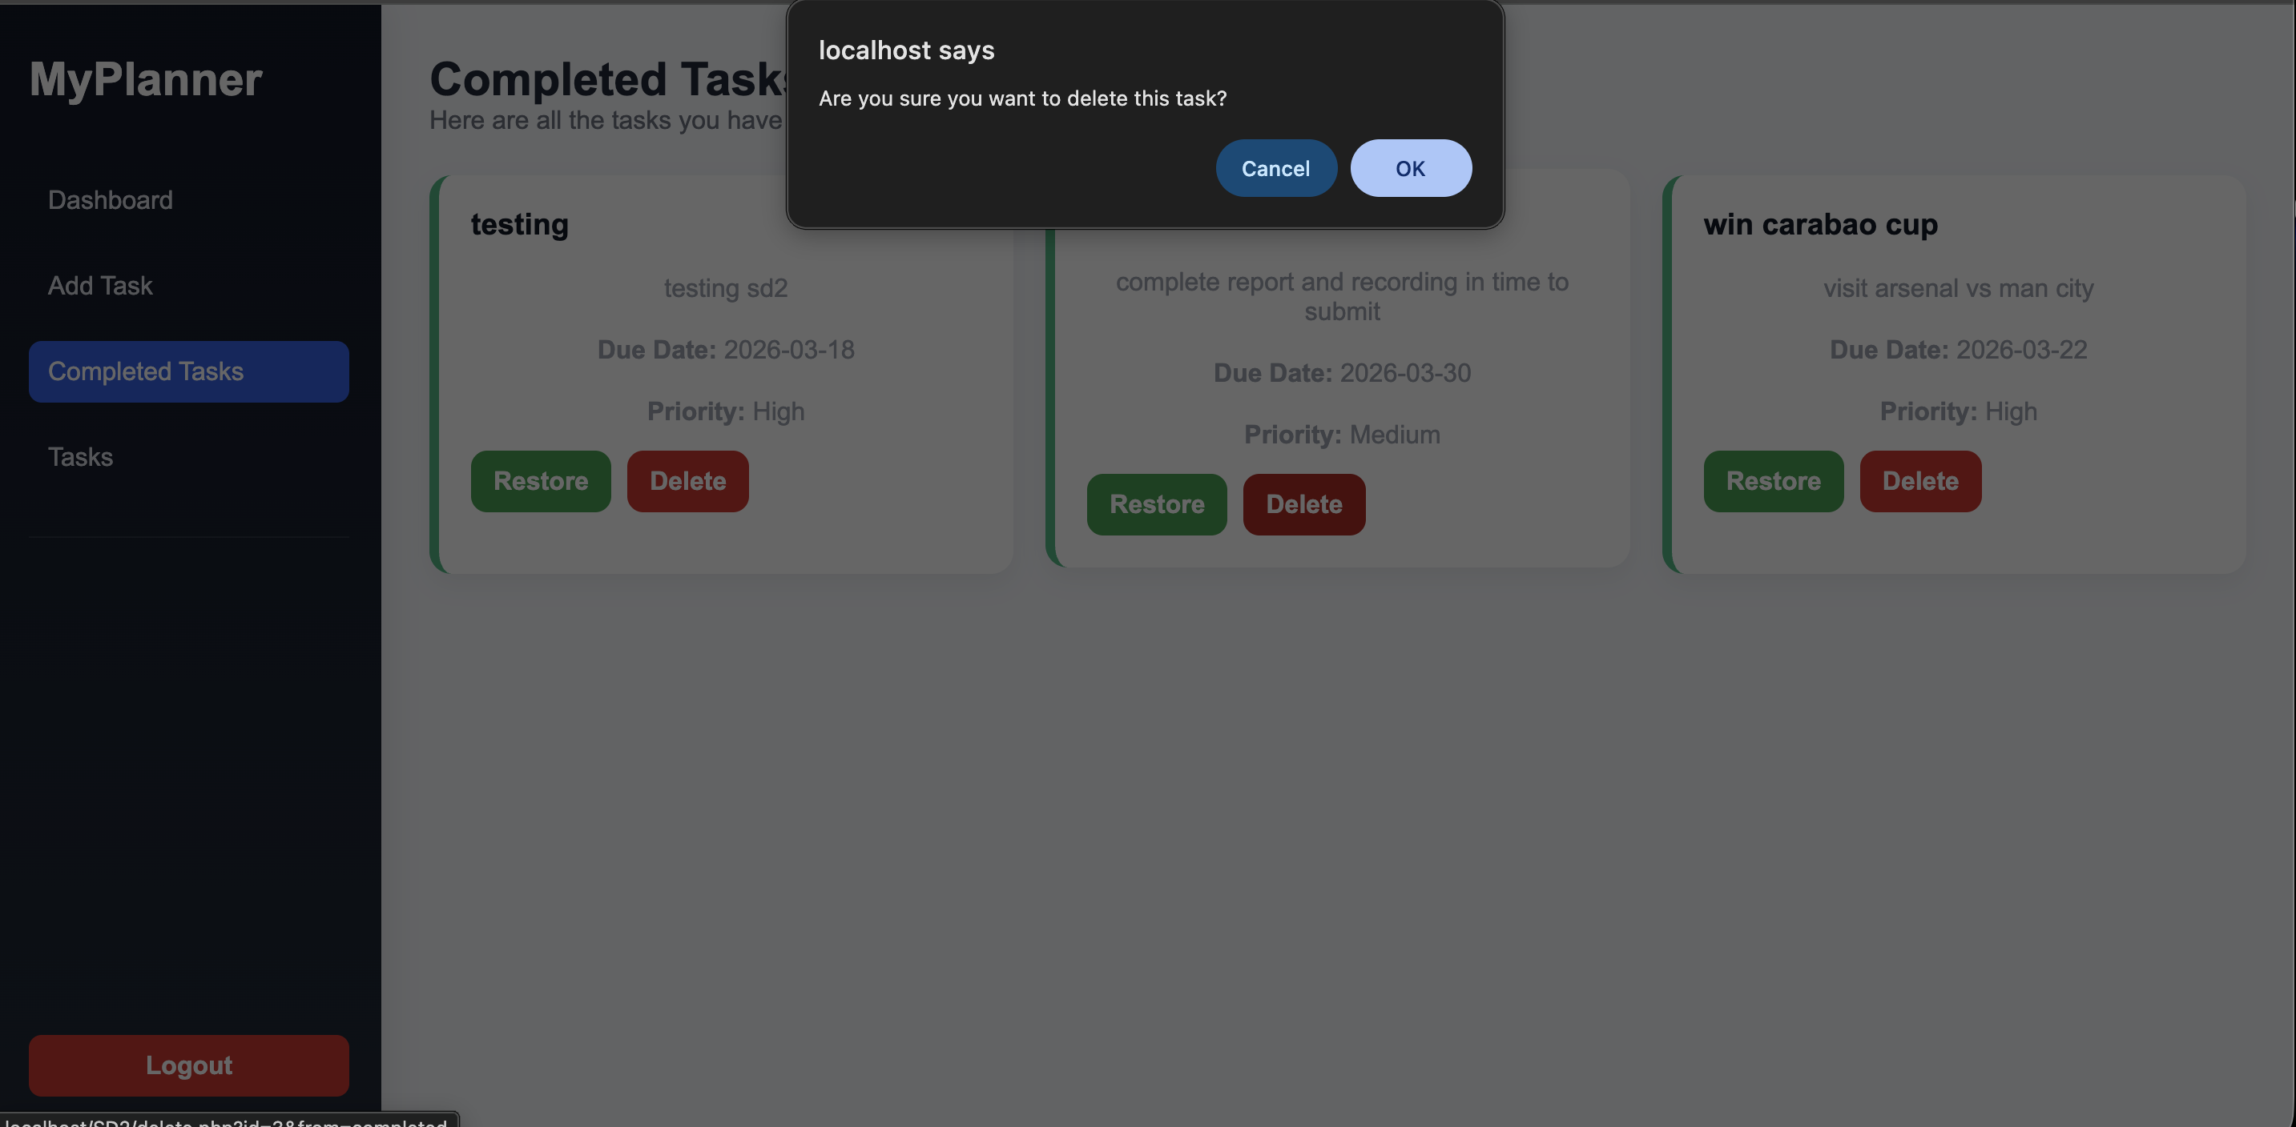
7 | Restore | Uncomplete | Click restore | Back to tasks | Works | Pass | 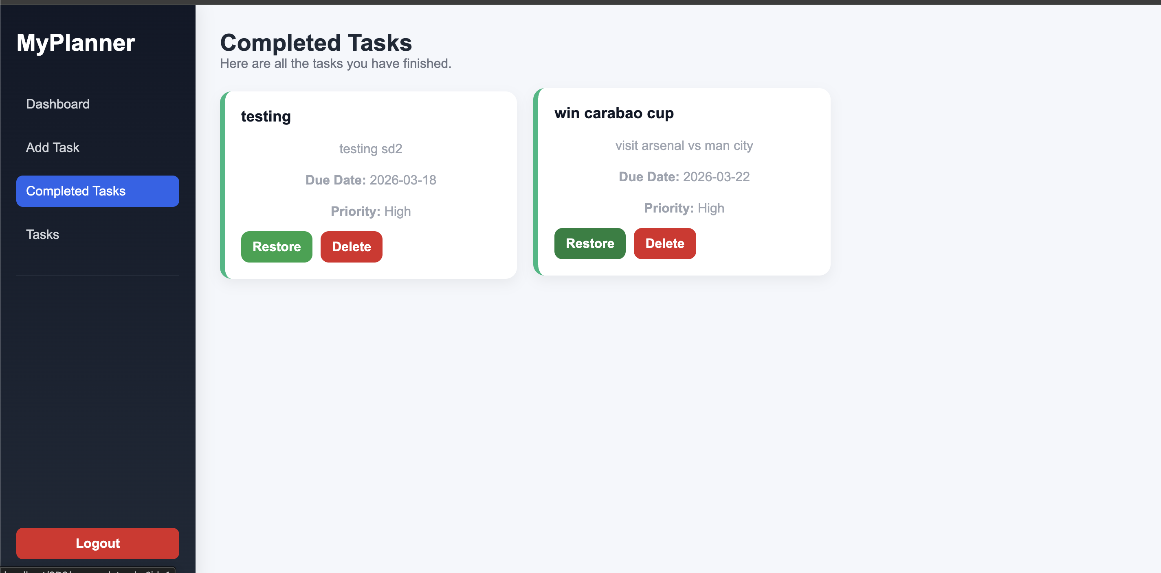
8 | Calendar | Mini calendar | Dates adjusted | New days tasks showing | Works | Pass | 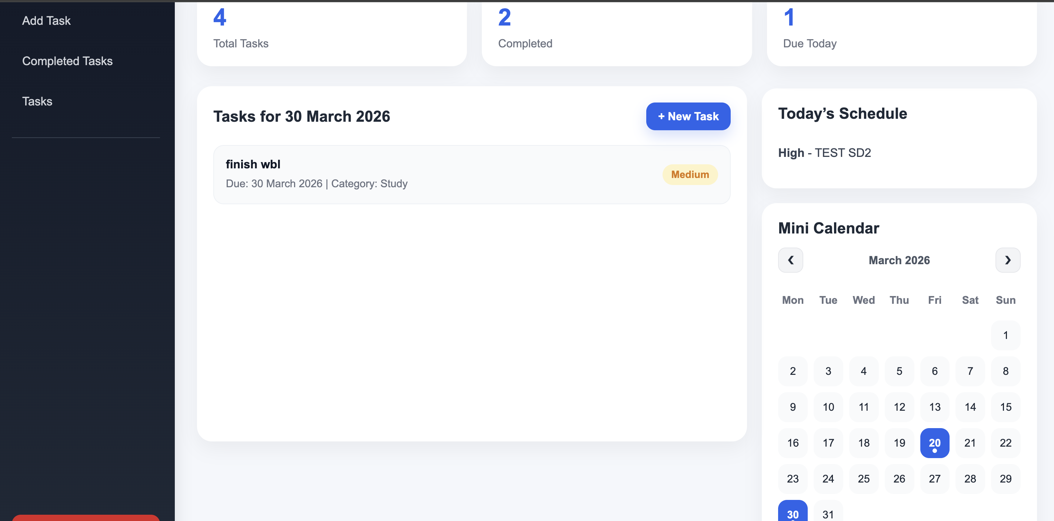
9 | Task category button link | test button on task category | click button | Tasks page | Works | Pass | 
10 | Security | Session check | No login | Redirect | Works | Pass | 